 | Prepared for Emma, Headland Yachting Limited  Project headlandyachting.com  Date 21 October 2026  First 5 reviews End of Friday 23 October 2026  Other 5 reviews Wednesday 28 October 2026  Lead David Balfour

Competitor website review

for Headland Yachting
Hi Emma. Before we design your site, we would love you to spend some time with the competition. You have a great eye, and your honest reactions to other charter websites (what you love, what makes you wince, and why) will shape your logo, your brand and every page we build. This guide walks you through it. We have kept it as light as we can.
Websites  10  Pick a mix, not just the ones you like. | Time per site  30–45 min  The first one takes longest. | Please  Type it  Type into the boxes so we can read it in later. | Deadlines  23 & 28 Oct  Five reviews by the end of Friday 23rd, the other five by the 28th.

1 Why we are asking
Every part of this review feeds a part of your new website. Your answers save us guessing, and save you rounds of changes later.
Your answers about… | …shape this part of your site
Logo, brand, colours, tone of voice | Your Headland Yachting logo, colours, fonts and brand messaging
Homepage, photography and video | Your homepage and video hero, and how we spend any imagery budget
Yacht search and filters | The yacht index: browsing and filtering the CYA fleet
Yacht detail page and booking | The yacht profile template and its enquiry form
Destination guides, blog ideas | Your BVI, USVI and Caribbean pages, and the 12 starter articles
Trust signals, about us | Your About page and the trust signals around the site
Contact methods, legal pages | Enquiry forms throughout, and your legal pages

2 How to fill it in
- Choose 10 websites. Section 4 has a list to start from. Aim for a mix: a few direct rivals, a couple of big fleet companies, one or two luxury brokers, and at least one site you dislike. Dislikes teach us just as much.
- Use one review sheet file per site. They are in the Review sheets folder, C01 to C10. Fill in the company name and link at the top, and add the company name to the file name.
- Do the five-second test. Before you click anything, jot down your gut reaction in section 1. First impressions are what your guests will have too.
- Try the test mission. Browse like a guest: find a crewed catamaran in the BVI for 6 guests for a week in late February 2027, with a budget of around $30,000. Using the same mission on every site makes them easy to compare.
- Type into the boxes: Likes, Don't like, Could be better, Other comments. Always say why. Short notes and bullet points are fine. Leave a box blank if you have nothing to say.
- Add screen grabs wherever a picture says it better (see section 3), with a one-line caption.
- Look at it on your iPhone for section 15. Most guests will see your site on a phone first.
- Fill in the quick scores and verdict last, then the "Pulling it together" pages at the end of this guide once you have done all ten.
- Send everything back as Word files: your review sheets plus this guide (for the last pages). Please send your first five sheets by the end of Friday 23 October, so we can start on the design, and the other five, with this guide, by Wednesday 28 October.

Your ten, as you go
Jot down your final choices here, so we know which sheet is which.
Sheet | Company | Website
C01
C02
C03
C04
C05
C06
C07
C08
C09
C10

Please type, don't handwrite
We will read your answers into our tools so we can compare all ten sites side by side and pull out patterns. That only works with typed text in the Word files.
So please: type straight into the boxes, keep the headings and box labels as they are, and send them back as .docx, not PDFs or scans. The boxes grow as you type, so write as much as you like.

If time is tight
Do the full sheet for at least five sites. For the rest, the details, quick scores, verdict and any section you feel strongly about are plenty.

3 Screen grabs on your Mac
A picture of what you mean saves a lot of words. Here are the shortcuts. Press the keys together.
Shortcut | What it does | Use it for
⌘ Cmd + Ctrl + Shift + 4 | Drag a box around what you want. It is copied, not saved. Click in a Screen grabs box in your review sheet and press ⌘ Cmd + V to paste. | The quickest way. Best for logos, menus, a single section.
⌘ Cmd + Shift + 4 | Drag a box. The picture is saved to your Desktop. | When you want to keep the files too.
⌘ Cmd + Shift + 4, then Space | The pointer turns into a camera. Click a window to capture all of it. | A whole browser window.
⌘ Cmd + Shift + 3 | Captures the whole screen. | Quick, but includes everything else on screen.
⌘ Cmd + Shift + 5 | Opens the screenshot toolbar. It can also record a video of your screen. | Recording search, filters or menus in action. Videos are too big for Word: save them in your folder (below) and name them in the caption.
Safari: File > Export as PDF… | Saves the whole length of a web page as a PDF. | A full homepage or yacht page.

A few tips
- Press Esc to cancel a screen grab halfway through.
- Always type a one-line caption under each picture saying what it shows and why it matters. We can read your words more reliably than your pictures.
- If a picture is huge in Word, drag a corner to make it smaller. We can still zoom in.
- If the document gets slow, click a picture, then Picture Format > Compress Pictures, and apply it to all pictures.
- If you save files (videos, PDFs, extra grabs), keep them in a folder per site, e.g. "C03 The Moorings", next to the review sheets, and send the lot back together (a shared folder or WeTransfer works well).

4 Suggested sites to review
Here are 15 to get you started. They are only suggestions: if you know others, including companies you have met at shows or that guests mention, please use them instead. Remember to include a couple you do not like.
# | Company | Website | Type | Why have a look
1 | Ed Hamilton & Co. | ed-hamilton.com | Broker (US) | Big Caribbean crewed specialist. Our worked example.
2 | Boatbookings | boatbookings.com | Broker (London, France, Florida) | International broker with a UK office and BVI/USVI crewed catamarans.
3 | Nautilus Yachting | nautilusyachting.com | Agency (UK, Kent) | UK independent agency selling the Caribbean to British guests in £.
4 | Virgin Island Sailing | virginislandsailing.com | Broker (Virgin Islands) | Crewed yacht broker focused on the Virgin Islands.
5 | Select Yachts | selectyachts.com | Broker (Florida) | Caribbean-focused luxury charters: a more polished, upmarket feel.
6 | CharterWorld | charterworld.com | Luxury directory | Huge luxury yacht listings: lots of content and search ideas.
7 | YachtCharterFleet | yachtcharterfleet.com | Marketplace (London office) | Comparison marketplace: see how it handles filters and yacht data.
8 | The Moorings | moorings.com/uk | Fleet operator (BVI base) | Market leader in the BVI. Big-budget design and booking.
9 | Sunsail | sunsail.com/uk | Fleet operator | Sister brand to The Moorings, aimed at a broader market.
10 | Dream Yacht Charter | dreamyachtcharter.com | Fleet operator | Large fleet across the BVI, Guadeloupe, Martinique and St Martin.
11 | BVI Yacht Charters | bviyachtcharters.com | Fleet operator (Tortola) | Local, independent BVI company: crewed and bareboat.
12 | Horizon Yacht Charters | horizonyachtcharters.com | Fleet operator (BVI, Grenadines) | Independent Caribbean company since 1998.
13 | Burgess | burgessyachts.com | Superyacht broker (London) | Aspirational: the top end of luxury, for style and tone.
14 | Northrop & Johnson | northropandjohnson.com | Superyacht broker | Another high-end benchmark for imagery and language.
15 | Med Charters (not Caribbean) | med-charters.com | Broker (Mediterranean) | Already on our list of good sites. Worth a look for style.

5 Worked example
On the following pages is a full review of Ed Hamilton & Co., a large US broker selling crewed Caribbean yachts. It shows the kind of detail that helps us most. Please don't feel you need to write this much: the "why" behind each comment is what matters.
Things we picked up that you might look out for on other sites:
- How they tidy up (or don't) the yacht data, since many brokers use the same central yacht database we will.
- Whether you can check dates and availability, and which currency prices are in.
- How long and fussy the enquiry form is.
- Where trust comes from: reviews, memberships, real people.

EX Worked example: Ed Hamilton & Co.
This one is ours
We have filled in this sheet ourselves so you can see the kind of feedback we are after. Yours can be much shorter: a few words in each box is fine. The important part is always the "why".
We reviewed the site on 21 October 2026. Sites change, so some details may differ when you look.

About this site
Company name | Ed Hamilton & Co. Yacht Charter Agents
Website  Landing page link | https://www.ed-hamilton.com/
Type of company  Broker, fleet operator, luxury, marketplace, other | Independent charter broker: bareboat, crewed and megayacht, worldwide but Caribbean-led
Based in | Maine, USA (phone number and About page)
Date reviewed | 21 October 2026
Checked on  Computer, iPhone, iPad | Computer (full width) and phone width
Why I picked it  Like it, dislike it, direct rival, other | Direct rival: sells crewed Caribbean yachts from the same kind of central yacht data we will use

Quick scores
Fill these in at the end. 1 = poor, 3 = fine, 5 = excellent. Leave blank if it does not apply.
Area | Score 1–5 | One-line reason
First impressions | 3 | Clear and tidy, but generic and a little dated
Logo | 3 | Distinctive ampersand, but old-fashioned
Brand, colours and feel | 2 | Trustworthy but corporate; nothing says Caribbean
Photography and video | 2 | One lifestyle photo on the homepage, no video
Tone of voice | 3 | Warm in places, but long-winded
Navigation | 3 | Everything is there, but hidden in a huge menu
Trust signals | 3 | Long history; no reviews; dates that contradict each other
Homepage | 3 | Search first, then very little else
Yacht search and filters | 2 | No dates or availability; mixed currencies
Yacht detail page | 3 | Great crew and menu content, messy raw data
Booking and contact | 2 | Enquiry only; long form
Destinations and blog | 4 | Big, practical library of guides and resources
On a phone | 3 | Handy sticky call/email bar; long text pages

1 First impressions
Your gut reaction in the first ten seconds, before you click anything. Is the page too busy, too basic or about right? What is your first impression of the company?
Likes and why  The search box sits right on the hero photo, so within seconds you know what the site is for. Lots of white space; it does not feel cluttered. | Don't like and why  It feels like a template from a few years ago. The ship's wheel, captain's hat and anchor icons are nautical cliché. A huge world map takes up a whole screen and tells me nothing.
Could be better and why  Lead with the Caribbean (their biggest market) rather than "worldwide". One stunning video or a few rotating images would make it feel far more special. | Other comments  Solid, experienced and trustworthy, but not desirable. It sells the expertise, not the dream.
Screen grabs paste here, with a one-line caption
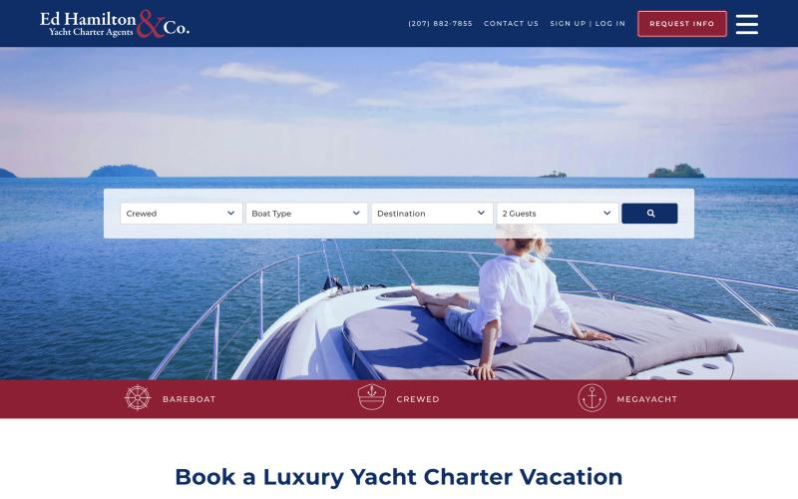
Homepage hero: search over a single lifestyle photo, with the three charter types in a red band below.
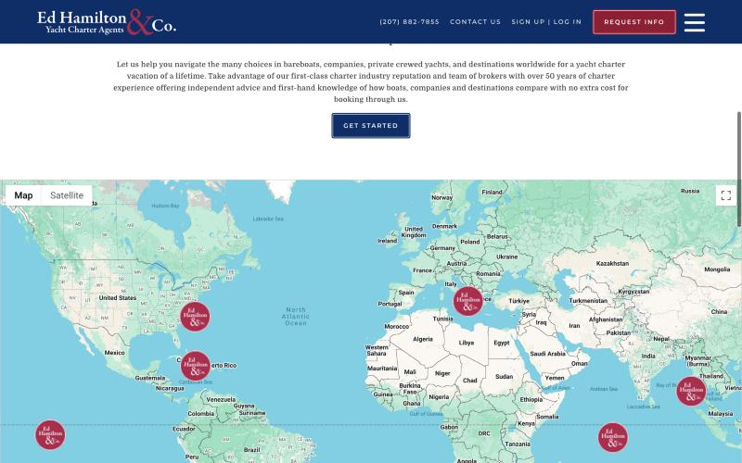
Full-width world map with logo pins. Decorative, and it pulls focus away from the Caribbean.

2 Logo
Grab a snippet of the logo. How big is it on the page? What message does it convey? What does it represent, or what do you think it represents? Would you remember it tomorrow?
Logo snippet paste a screen grab of the logo

Ed Hamilton & Co. logo, taken from the header.
Likes and why  The big red ampersand is distinctive and memorable, and it is the only real bit of personality. The serif lettering says established, traditional and trustworthy. | Don't like and why  "Yacht Charter Agents" is tiny and hard to read at header size. It is a person's name, so it says nothing about the sea, the Caribbean or luxury.
Could be better and why  A simpler mark (the ampersand on its own) would work better as a browser icon and on social media. | Other comments  For us: a founder-led brand can work (Emma is the brand), but then the logo has to carry the feeling.

3 Brand, colours and feel
A brand is more than a logo. It is the whole impression a company leaves you with: its personality (relaxed and barefoot, or polished and exclusive), who it seems to be for (families, honeymooners, first-timers, seasoned sailors), what it promises (expert advice, best price, the holiday of a lifetime), and whether everything (logo, colours, photos, words) feels like it comes from the same place. A good test: if this company were a person, who would they be? Then the colours: which are used, and how do they make you feel? Warm, friendly, luxurious, practical, calm, corporate, dated, fresh? Does it feel like the Caribbean?
Main colours e.g. navy, coral, sand
Navy blue, deep red, white, pale grey and pink-tinted panels
Feel words e.g. warm, luxurious, practical
Practical, traditional, nautical, trustworthy, a bit corporate
Likes and why  A clear promise: "sound advice is priceless... ours is FREE". Independent, impartial advice is the core idea, and the About page backs it up.  Navy and white feels calm and maritime, and the contrast makes it easy to read. | Don't like and why  The brand is all about the company and its history, not the guest's holiday. "Luxury" headline, but much of the content is practical bareboat information.  The deep red band is heavy, and the pink-tinted panels clash with it. Nothing feels like the Caribbean: no turquoise, sand or warmth.
Could be better and why  Pick an audience. They try to speak to bareboat sailors, families, honeymooners and superyacht clients all at once.  Bring in colour from the islands, used sparingly, so it feels warm as well as trustworthy. | Other comments  If it were a person: a knowledgeable, slightly old-school travel agent in a blazer. Reliable, but not someone you would dream with.
Screen grabs paste here, with a one-line caption
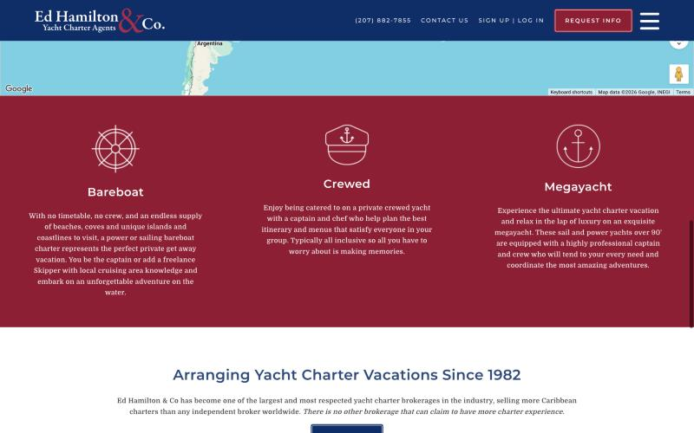
Red band with line icons for bareboat, crewed and megayacht charters.

4 Photography and video
Quality and style of the photos. People enjoying themselves, or just the boat? Stock or real? Any video? Do the pictures make you want to go?
Likes and why  The hero photo (a guest relaxing on the bow) sells the feeling of switching off. Yacht pages have lots of photos, including a deck plan. | Don't like and why  Only one lifestyle image on the homepage. Yacht photos vary a lot in quality and crop because they come from the owners. No video anywhere I could find.
Could be better and why  A small set of carefully chosen lifestyle images, and a consistent crop for yacht photos in the search results. | Other comments  A good argument for spending some of our budget on premium imagery or video (see the quote, section 4).
Screen grabs paste here, with a one-line caption

5 Language and tone of voice
How do they talk to you? Formal or chatty, expert or salesy, short or long-winded? UK or US English? Copy and paste any words or phrases you love, or that make you wince.
Likes and why  Warm and personal in places: "who you spend your vacation with matters". The practical guides are clearly written by people who have done it. | Don't like and why  Very long paragraphs and tired phrases ("vacation of a lifetime", "making memories"). US English and dollars throughout: fine for American guests, but would feel wrong for a UK company.
Could be better and why  Shorter sentences, specific details, and fewer superlatives. | Other comments  For us: we need to decide early on UK or US English, and $ or £, based on where most guests come from.
Screen grabs paste here, with a one-line caption

6 Navigation
Can you find things easily? Is the menu clear? Do you always know where you are and how to get back?
Likes and why  Phone number and "Request info" button are always visible in the header. Breadcrumbs show you where you are. | Don't like and why  On a computer the menu hides more than 100 links behind a hamburger icon. The destinations list includes Croatia, Thailand and more, which dilutes the Caribbean focus. Page style is basic: a lot of plain text.
Could be better and why  A short top menu (Yachts, Destinations, About, Journal, Contact) that is always visible on a computer. | Other comments
Screen grabs paste here, with a one-line caption

7 Trust signals and the people
What makes you trust them, or not, and why? Look for reviews, testimonials, awards, memberships (e.g. MYBA, CYBA), years in business, company details, press. And the About page: how do they tell their story, and can you see who you would be dealing with?
Likes and why  "Arranging yacht charter vacations since 1982" and "more Caribbean charters than any independent broker". Membership pages for CYBA and AYCA. Real crew names and photos. A clear disclaimer about rates.  An authentic founder story: Ed sailed from England to Tortola in 1972 and worked in every part of the industry. | Don't like and why  No reviews, testimonials or ratings on the homepage or yacht pages. The facts contradict each other: the About page title says "since 1972", the homepage says 1982, and the text says "36 years in the industry", which makes me wonder how up to date the site is.  The story stops years ago, the dates do not match, and the current team is not front and centre.
Could be better and why  Show reviews and membership logos where decisions happen, for example next to the enquiry button.  Photos of the brokers, each with a personal note about the yachts and islands they know. | Other comments  For us as a new company, trust has to come from Emma personally: her face, story, experience, a UK-registered company, and any memberships.  Our About page is Emma: her story, her eye as an artist, and her personal approach.
Screen grabs paste here, with a one-line caption

8 Homepage
Work down the landing page. What do they show first, and in what order? Is the main message clear? Is there an obvious next step (search, enquire, call)? Does the hero image or video sell the dream?
Likes and why  Search comes first. Three clear paths: bareboat, crewed, megayacht. | Don't like and why  After the hero it is a paragraph of text, the map and the footer. No featured yachts, destinations, reviews or articles. It feels short and thin.
Could be better and why  Featured yachts, destination highlights, a review or two, latest articles, and a clear "talk to us" call to action. | Other comments
Screen grabs paste here, with a one-line caption

9 Yacht search and filters
Try the test mission (section 2). Which filters are there? Can you search by dates and see availability? Are prices clear, and in which currency? How are results shown? Did you find a suitable yacht easily?
Filters offered e.g. type, guests, budget, dates
Charter type, boat type (sailing catamaran, monohull, motor yacht, power catamaran), destination, guests. A "Filters" panel adds boat name, captain name, chef name, cabins and length. Sort by price.
Availability can you check dates? how?
None. You cannot enter dates or see what is free.
Likes and why  Searching by captain or chef name is a clever touch for repeat guests. Result cards show the key facts (guests, cabins, length, air con, crew, year built). A heart icon lets you shortlist yachts and send them to a broker. | Don't like and why  No dates or availability, so you cannot tell what is actually free. 538 results across 45 pages. Prices mix $ and €, and one card shows "$0 – $34,500".
Could be better and why  Dates and a budget slider, one currency, and fewer, better-curated results. | Other comments  Availability is exactly where we could beat them, if the CYA feed supports it.
Screen grabs paste here, with a one-line caption
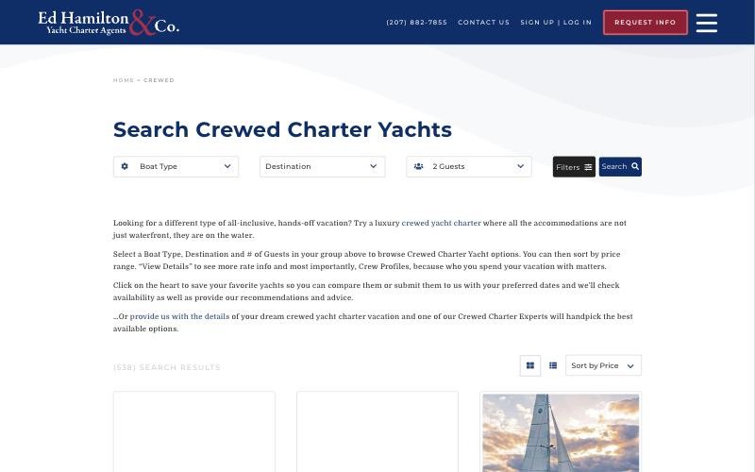
Crewed search page: boat type, destination and guests, with a separate Filters button.
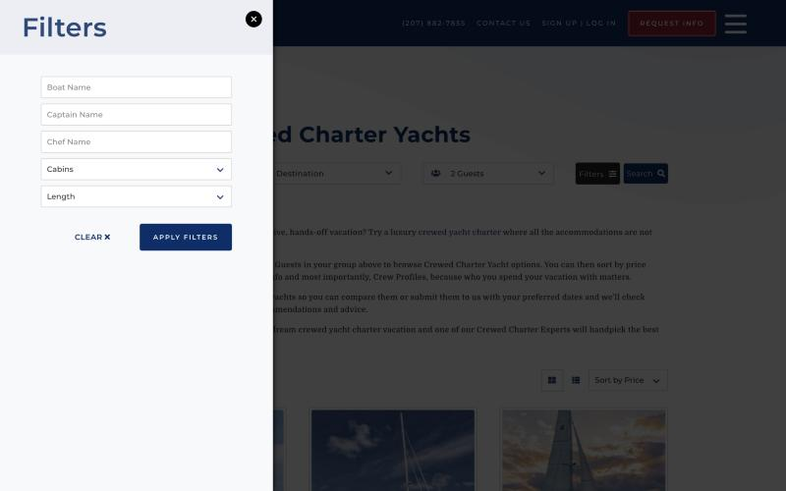
The Filters panel: boat, captain and chef name, cabins and length. No dates or budget.
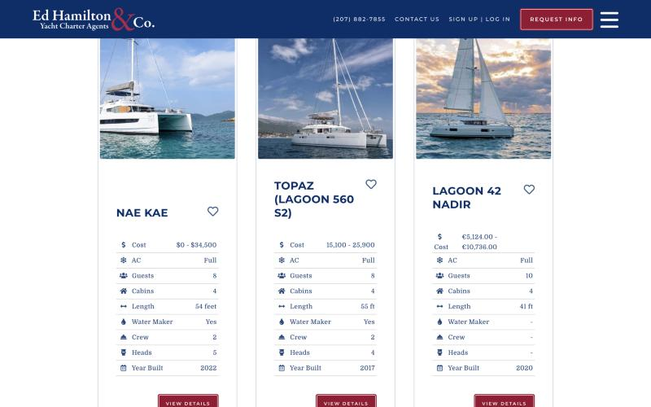
Result cards. Note the "$0 – $34,500" price on the first card and the mix of $ and €.

10 Yacht detail page
Open two or three yachts. How is the page laid out? What is there: photos, video, deck plan, crew, menus, rates, toys, reviews, availability? Is it easy to take in? What is missing?
What's on the page photos, video, deck plan, crew, menus, rates, calendar, reviews, enquiry form…
Photo carousel (including a deck plan), key facts bar, weekly rates by season and number of guests, extra rate information (tips, meal plans, Christmas and New Year), location, tabs for crew profiles with photos, specifications, accommodation and sample menu, and a long list of amenities and toys. No video, availability calendar, reviews or enquiry form on the page.
Likes and why  Crew profiles with photos, and sample menus: on a crewed charter the people and the food are what you are really buying. Rates by number of guests make it clear what you will pay. | Don't like and why  It reads like a raw data dump: "0 — Onboard WIFI", "Tp In Heads: Yes" and "$0/week" for 9 and 10 guests. The rates table is cut off on the right at full computer width. You have to scroll a long way.
Could be better and why  Turn the feed labels into plain English, hide empty fields, and put an enquiry button next to the price. | Other comments  This looks like the same kind of data we will get from the CYA feed. Big lesson: we must tidy up and design around the raw data, not just print it.
Screen grabs paste here, with a one-line caption
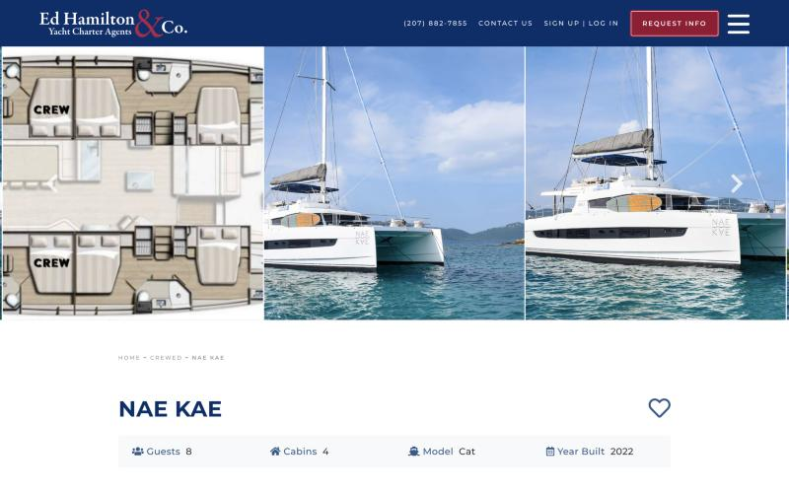
Yacht page (Nae Kae): photo carousel starting with the deck plan, then name and key facts.
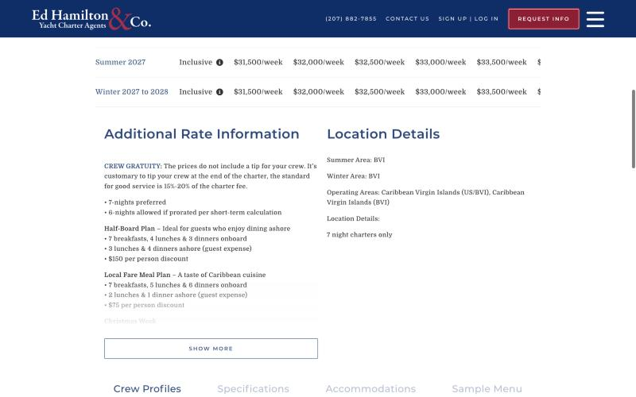
Rates by season and guest numbers. The table runs off the right edge of the page.
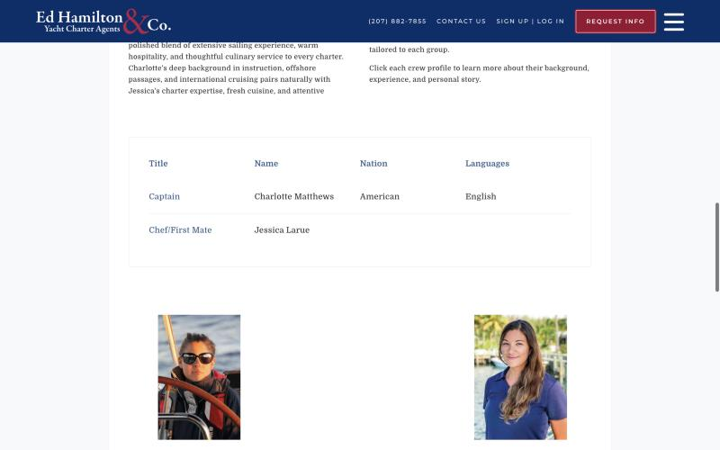
Crew profiles with names, nationality, languages and photos.

11 Booking process
How do you actually book? Instant booking, enquiry form, "check availability", hold a date, create an account, pay a deposit? How many steps? Would you know what happens next?
How booking works describe the steps
No online booking. Either save yachts as favourites and submit them (needs an account), or fill in the "Request Boat Info" form. A broker then replies with options.
Likes and why  Personal service: a real person handpicks the yachts for you. | Don't like and why  You cannot check availability or hold a date. Having to create an account just to save favourites is a barrier.
Could be better and why  A "Check availability" button on every yacht that fills in the form with that yacht's name. | Other comments  Same model as ours (enquiry, not online payment), so the enquiry step must feel effortless and quick.
Screen grabs paste here, with a one-line caption

12 Contact methods
Which ways can you get in touch? Forms (how long, what they ask, do they seem to work), live chat, phone, WhatsApp, email, call-back, opening hours and time zones. Please don't send pretend enquiries: just review what you see.
Methods offered form, chat, phone, WhatsApp, email…
Phone (US number) in the header and in a sticky bar on phones, email, Request Boat Info form, Contact page, Give Feedback form, Facebook and Instagram. No live chat or WhatsApp that I could see.
Likes and why  The phone number is always visible, and on a phone the sticky bar has call and email buttons. | Don't like and why  The enquiry form is long: around 20 fields, including full postal address and "confirm email", before you have even spoken to anyone. US number only, with no opening hours or time zone.
Could be better and why  A short first form (name, email, dates, guests, message), and WhatsApp, which is popular with charter guests. | Other comments  We did not submit the form; we only looked at it.
Screen grabs paste here, with a one-line caption
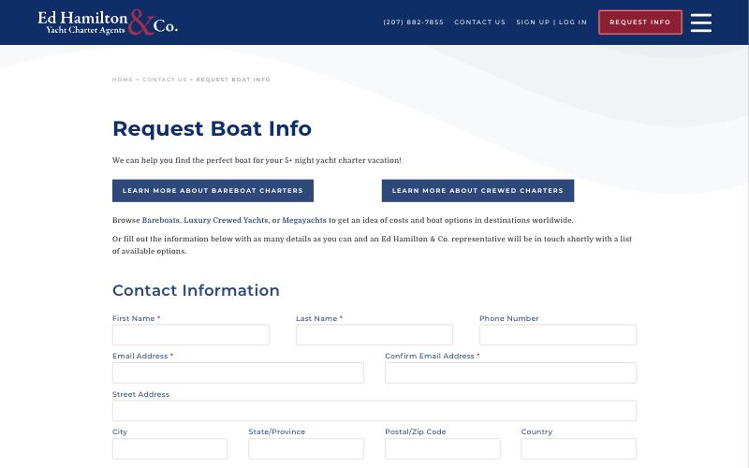
Request Boat Info form. This is only the top; it carries on with charter details, dates and a newsletter opt-in.

13 Destination guides and blog
Do they have pages on the BVI, USVI and wider Caribbean? Inspiring, useful, or filler? Is there a blog: how often do they post, on what, and is it worth reading? Note any article or guide that would make a good theme for our site in the table underneath.
Likes and why  A huge library. The Caribbean is broken down properly: Bahamas, Virgin Islands (USVI, BVI, Spanish Virgin Islands), Leewards, Windwards and Grenadines. Practical pages too: BVI ferry schedule, fishing licence, passports, tipping.  Real charter stories ("Guests aboard … had the time of their lives") that name the yacht: social proof and good for search engines. Posts introducing new yachts. | Don't like and why  All the worldwide destinations dilute their Caribbean expertise.  No dates on posts, so you cannot tell if the blog is active. Text-heavy cards, and some cards have no image.
Could be better and why  Link each guide to the yachts that sail there.  Dates, categories, and a big image on every post. | Other comments
Screen grabs paste here, with a one-line caption
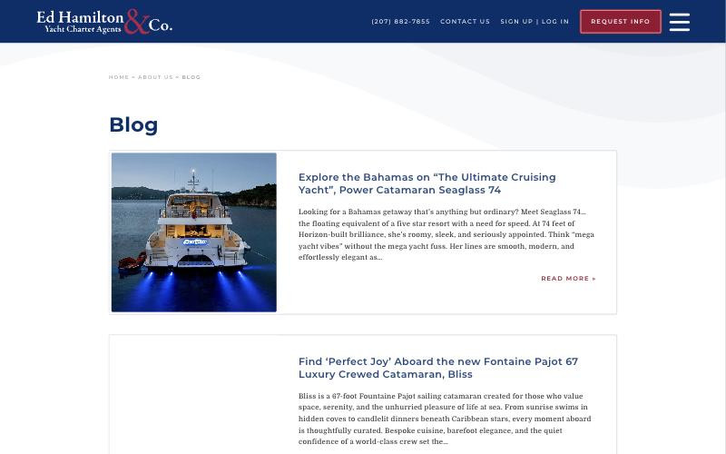
Blog index: one large card per post, no dates.
Ideas for our blog and destination guides
Article or guide theme | Link | Why it would work for us
Meet the crew: a series on individual crews | ed-hamilton.com/about-us/blog/ | On a crewed charter the crew is the product. Great for trust and for search.
Cruise ship or private yacht? | ed-hamilton.com/resources/cruise-ship-vs-charter/ | Wins over people who have never considered a yacht.
Your first charter: what to expect | ed-hamilton.com/resources/first-time-charterers/ | Answers the nervous first-timer's questions.
Tipping your crew: a simple guide | ed-hamilton.com/resources/tipping/ | Everyone wonders; UK guests are often unsure about 15–20%.
Charters by occasion: family, honeymoon, food lovers | ed-hamilton.com/crewed-charters/charters-by-occasion/ | Ready-made pages for different audiences.
BVI or USVI: which is right for you? | ed-hamilton.com/charter-destinations/caribbean/virgin-islands/ | Helps undecided guests choose, then points them to yachts.
Getting to the BVI from the UK | (gap: nobody covers this well) | Exactly the question a UK guest asks first.

14 Legal pages
Look in the footer: privacy policy, cookie policy and banner, terms and conditions, booking terms, accessibility statement, company name, number and address. Easy to find? Readable?
Pages found list what you found
Privacy policy, terms and conditions and sitemap in the footer. Rate disclaimer on yacht pages. Consent tick box on the form. I did not notice a cookie banner, an accessibility statement or a company address in the footer.
Likes and why  The rate disclaimer is clear and sensible. | Don't like and why  No company details (registered name, address) in the footer.
Could be better and why | Other comments  For us: as a UK company, Headland Yachting Limited should show its company name, number and registered office on the site. We draft generic legal pages (see the quote), which a legal adviser should check.
Screen grabs paste here, with a one-line caption

15 On a phone
Open the site on your iPhone. Is it as good as on the computer? Easy to tap, read, search and get in touch?
Likes and why  The sticky bottom bar (email, call, account, menu) is genuinely handy. Text is large and readable. | Don't like and why  The About page is one long wall of text on a small screen.
Could be better and why | Other comments
Screen grabs paste here, with a one-line caption
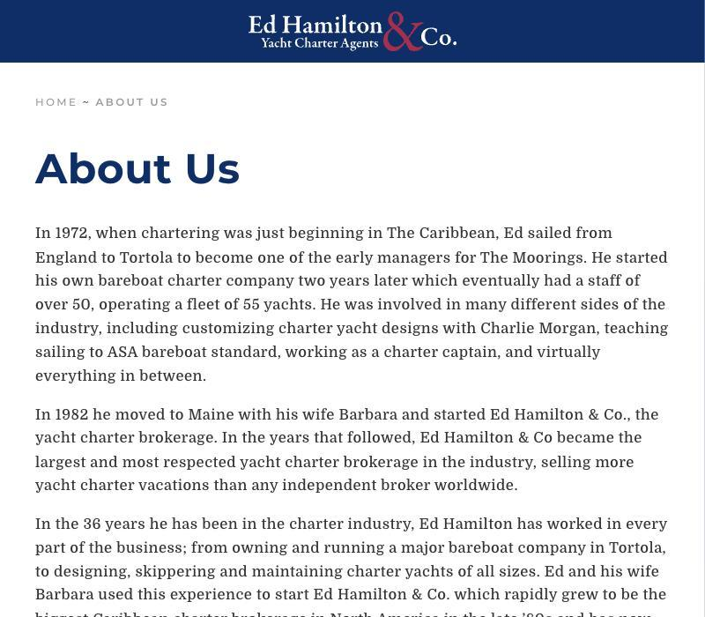
About page at phone width.

16 Anything else
Anything else about this site that makes it good or bad: clever features, annoyances, speed, pop-ups, personality.
Likes and why  The favourites shortlist, and "Specials" pages for bareboat and crewed deals. | Don't like and why  There is a lot of information, but no easy way to compare two yachts side by side.
Could be better and why  A simple compare feature for two or three yachts. | Other comments
Screen grabs paste here, with a one-line caption

17 Verdict
Be honest. A low score with a good reason is more useful to us than a polite one.
How likely would you be to book using this site?  Score 0–10, and why | 6 / 10. I would trust them, and the crew and menu details are great, but I would have to phone or email just to find out what is available.
How happy would you be if this was your company website?  Score 0–10, and why | 3 / 10. It works, but it does not look or feel like a luxury Caribbean holiday, and it is not the first impression I would want to give.
Top 3 things to steal | 1. Crew profiles and sample menus on every yacht  2. Rates shown by number of guests  3. Practical guides: tipping, ferries, first-timers
Top 3 things to avoid | 1. Raw feed data printed as-is  2. A long enquiry form  3. No dates or availability in search
This site in one sentence | Expert and trustworthy, but it feels like a catalogue rather than a holiday.

6 Your review sheets
Your ten blank review sheets are separate Word files, C01 to C10, in the Review sheets folder that came with this guide. Each has exactly the same sections as the worked example, so we can compare sites like for like.
Why separate files? Screen grabs from a Mac are large. Ten sites full of pictures in one document would make Word slow and the file hard to email.
- Open C01 for your first site, add the company name to the file name (e.g. "C01 The Moorings.docx"), and fill it in.
- Short on space in a box? Just keep typing; it will grow.
- Want to review an eleventh site? In Finder, select a blank sheet, press ⌘ Cmd + D to duplicate it, and rename it C11.

7 Pulling it together
Once you have reviewed all your sites, take ten minutes on this page. It is the most useful page in the whole review for us.

Your top three sites
Rank | Site | What makes it the best
1
2
3

Feature wish list
Features you saw (or wished you had seen). Examples: availability calendar, WhatsApp, video tours, compare yachts, reviews, sample itineraries, price in £.
Must have | Nice to have | Don't want

Brand personality
Where should Headland Yachting sit between each pair? Type an X in one box per row.
 | 1 | 2 | 3 | 4 | 5
Classic |  |  |  |  |  | Modern
Exclusive |  |  |  |  |  | Approachable
Understated |  |  |  |  |  | Bold
Serious |  |  |  |  |  | Playful
Adventure |  |  |  |  |  | Relaxation
Nautical |  |  |  |  |  | Lifestyle
Quintessentially British |  |  |  |  |  | Laid-back Caribbean

In your words
Three words
You would love guests to use about Headland Yachting
Words to avoid
You never want associated with us
Photography style
What should our pictures feel like? Links to images you love are welcome
Biggest surprise
Anything you did not expect
Questions for us

8 While you are in the zone (optional)
We will need these for the build anyway (see "What we need from you" in the quote). If you have answers to hand, adding them now saves a round of emails.
Your guests
Where are they from? Families, couples, groups? First-timers or experienced?
Currency
Show prices in $, £ or both?
UK or US English
Which will most of your guests expect?
Your story
A few bullet points for the About page: how you got here, what makes you different
Email addresses
e.g. emma@ and charters@
Where enquiries go
Which email address should forms send to?
Analytics
Umami (no cookie banner) or Google Analytics?
Your own photos and video
Anything you own and are happy for us to use
Memberships and credentials
Industry bodies, qualifications, awards: good trust signals
Social media
Accounts or handles you have, or want

Thank you, Emma. Any questions at all, just ask. David and Julia, Media Dreams. hello@mediadreams.co.uk

